Table of Contents
EIB CS10.5 Detailed Upgrade Guide _ Pre-Prod 3
APPENDIX A 12
CS PROD database user schema changes 12
APPENDIX B 13
Form Templates db upgrade 13
APPENDIX C 15
Index all from pre-prod db backup date 15
APPENDIX D 16
Elink configuration on the cluster 16
[loader] load=sockserv #load=sockserv;agents;notify;wfagent;spchange;RecyclebinAgent;Agent4EIFinvoices;wrscheduleagent;wrcollectionagent;processPdfAgent #load=sockserv;;wrscheduleagent;wrcollectionagent #load_relagent=relagent #load_distributedagent=distributedagent #load_daagent=daagent #load_verify=verifyAgent 19
APPENDIX E 20
Configuring eSign in a Clustered Environment 20
APPENDIX F 23
To remove all Admin servers and related entries from a CSinstance 23
APPENDIX G 26
Content Server 10.5 Instance install guide 26
https://ged.beilux.eib.org/ged/ged.dll/open/66734917 26
APPENDIX H 27
Backup Manager scheduling 27
Load-Balancer configuration 27
Replacing based keep-alive scripts on each front-end server 27
APPENDIX I 27
Add Storage Providers 27
APPENDIX J 33
APPENDIX K 34
Set agent to run off their own threads 34
APPENDIX M 35
Uninstall modules that can’t be upgraded or are no longer required 35
APPENDIX N: Disabling and Enabling Appearances 36
APPENDIX O: Disabling custom column 'WNF_PQPublisher' 37
Not applicable 37
APPENDIX P: Disabling custom Facet and column (PR Status and PR Publisher) 38
APPENDIX Q: Update DAUDITNEW archive tables and view 39
APPENDIX R: Reset GUID for to resolve webedit issue 43
APPENDIX S: Configure Rendition Folders 43
APPENDIX T: Configure Multifle setting 44
APPENDIX U: Migrating index from cs10 to cs10.5 44

EIB CS10.5 Detailed Upgrade Guide _ Pre-Prod
Note: All steps completed by CS Admin unless stated
INSTRUCTIONS | COMMENTS | TIMINGS | Status | End time
Build CS10.5 Cutover instance and connect to a dummy database.  Install modules all the optional Module and any custom module that can be upgraded |  | NA | Done
Run CS database verification level 4 to ensure no errors :  To done prior to the upgrade | SYS Admin | 12h | Done
Run verify db fix script  See Appendix J | SYS Admin | 3h | NA
Run CS database verification level 4 to ensure no errors after applying the OT fix | SYS Admin | 12h | NA
Verify the Enterprise Index this can schedule 1 month before the go live, ensure not missing item from the index verification | SYS Admin | 12h
Build an x number of FE CS10.5 vanilla instances with all final optional modules and with custom module connect to dummy databases. |  | 7 days | Done
Snap mirror or robocopy EFS (CSfile store) into the New environment | (Storage Team) |  | Done
Export CS_Prod schema from Production environment :  - Creation of an empty database : 30 min  - Export (datapump) of the schema LLMAINP : 4h08  Issue:  ORA-39346: data loss in character set conversion for object SCHEMA_EXPORT/TABLE/STATISTICS/TABLE_STATISTICS → linked to a bug (but I didn’t have to import the statistics)  Processing object type SCHEMA_EXPORT/TABLE/STATISTICS/USER_PREF_STATISTICS  ORA-39082: Object type PROCEDURE:"LLMAINP"."CHECKBLOBVALUE" created with compilation warnings → already invalid on the source environment  ORA-39082: Object type PROCEDURE:"LLMAINP"."CHECKBLOBVALUE" created with compilation warnings→ already invalid on the source environment  ORA-39082: Object type VIEW:"LLMAINP"."QUERY_REWRITE_VW" created with compilation warnings→ already invalid on the source environment | (DBA) | 4h | Done
Import CS_Prod schema (ensuring table ownership stays the same) into Dev environment, Oracle Database 12 c server set to AL32UTF8 character set  - Import (datapump) of the schema LLMAINP : 2h30  - Creation of a database link to recreate the other users + creation of the other users  - calculation of the statistics on the full database (elapsed time : 30 minutes) | (DBA) | 3h00 | Done
Uninstall all the module that can’t be upgraded see APPENDIX M Error: Reference source not found | SYS Admin | 2h | Done
drop custom database tables, custom indexes and remove any custom column added to cores table APPENDIX N |  | 30 min | Done
Run the attached script to remove all admin server entries and create a new default one, then delete admin server files from config folder, script:  See APPENDIX H | SYS Admin | 30 min | Done
Connect CS 10 cutover instance on vmd-ged-02 to a copy of production CS schema on an Oracle 12c Server as follows:  - Update tnsnames values on staging server, with Oracle 12c UTF8 service descriptor (GED oracle server), that contains a copy of Production CS schema.  - Copy ldap.ora file from dev box  - Stop CS10sp2 staging instance  - Go to select existing database page and switch to the production database (livelink_prod on Oracle 12c)  - Stop Local Oracle services from the services console  - Deleted dummy Admin Server and Enterprise Data Flow when requested, after connecting to livelink_prod Oracle 12C schema  - Enable logging and set debug=2 | SYS Admin | 30 min | Done
Change the CS services user to a service user network account. | SYS Admin | 10 min | Done
Modify the GUID in order for webedit to work correctly  APPENDIX R Error: Reference source not found |  | 10 min
- Connect CS instance to Pre-Prod EFS (listed below), go to ?func=storage.storageproviders and update all the external shares or run the script in APPENDIX I  - Update the efs configuration  - Download a file to check EFS connection  Empty log folder  - Uninstall any customisation and optional module that can’t be upgraded on the cs10 cutover instance. | SYS Admin | 30min | Done
Disable and Enable Appearances See Appendix N | SYS Admin | 30 min
Delete the Admin Help and User Help Indexes | SYS Admin | 30 min
Delete the Admin Help and User Help Indexes from the recycle bin | SYS Admin | 30 min
Disabling custom column 'WNF_PQPublisher' See Appendix O not application as the issue is now resolved with the full EFS replication | SYS Admin | NA
Stop Processes |  | 10 min
Stop CS 10 CS Services :  • Extractors  • Directory Walkers  • XML Activators  • DCS  • Admin servers  • Update Distributors  • Index Engines  • Search Federators  • Search Engines | SYS Admin | 10 min
Suspend the Enterprise Data Flow Manager. |  | 10 min
Stop the Enterprise Search Manager |  | 10 min
Stop the Memcacheds |  | 10 min
Ensure that no other processes are running |  | 10 min
Stop the Content Server Admin services |  | 10 min
Backup the Content Server preprod 10.5.0 Index |  | 1h
CS 10.5 Go to the local oracle client ...\network\admin\ directory and  Add new service descriptor to tnsnames.ora file, | SYS Admin | 10 min
Stop CS 10.5 services |  | 10 min
On cs 10.5  Add to [Lang_en_US] section the following rows:  LL_ENCODING=UTF-8  LL_MULTIBYTE=TRUE  LL_INTLSTRINGS=TRUE  HTMLCharset=UTF-8  ENV_NLS_LANG=.AL32UTF8  LL_LC_COLLATE=English | SYS Admin | 10 min
Empty logs folder,  Edit opentext.ini file and change the two parameter values:  [general]  debug=2  [Options]  wantlogs=true | SYS Admin | 10 min
Run DB stats : EXEC dbms_stats.gather_schema_stats('LLMAINP', cascade=>TRUE); | SYS Admin | 5h
Take a snapshot/backup of the database | (DBA) | 3h
Remove  [general]  dftConnection=llmainp  [dbconnection: llmainp]  From cs_home\config\otclusteragent folder, delete: .otclustergaent.properties  From cs_home\config\ folder, delete:  otadmin.cfg  otadmin.cfg.old  otadmin.pid  otadmin.pid.old | SYS Admin | 10 min
Copy the LLFieldDefinitions.txt and LLFieldDefinitions_EL.txt from cs10 admin server to cs 10.5 admin server |  | 10 min
Reconcile CS 10 and CS10.5 opentext.ini files  #align entire opentext.ini file | SYS Admin | 1h
Start the cs 10.5 services | SYS Admin | 10 min
Connect to the 10.0.0 Database | SYS Admin | 10 min
Start the DB upgrade | SYS Admin | 4h
Restart CS services when requested | SYS Admin | 10 min
Disable Facets and Column PR Status and PR Publisher see Appendix P | SYS Admin | NA
Install all the custom modules and optional module that could not be upgraded | SYS Admin | 1h
Upgrade Recycle Bin Schema  func=recyclebin.database | SYS Admin | 1h
Purge the recycle bin Volume to 1 day (not applicable)  Truncate notification tables | SYS Admin | NA
Update DAUDITNEW archive tables , DAUDITNEW View, modified WEBNODES_EN
see Appendix Q
Install any new modules | SYS Admin
Resynchronise Admin Server  If memcache doesn’t work, stop and start the process from admin pages.  double check the firewall rule  Align Extractor and esign section. | SYS Admin
Create Enterprise Data source and then  - Go to Enterprise Partition Map > Properties > Metadata Memory Settings and edit the Read/Write settings. Move OTHP and OTSummary regions to “Disk Retrieval” and apply changes.  - Create 10 partitions, maybe start with 8 to ensure they fill up and create 2 more towards the end. On the Go Live weekend, restore Pre-Prod Index and run script in APPENDIX C to trigger index update of last few months.  - As recommended by OT for CS10.5 leave partitions in Read/Write mode (and let the automatic “Update only” control for read/write mode kick in at 70% full with rebalancing occurring above these levels.) | SYS Admin
Create 6 partitions, 6 index engine, 6 search engine. In Dev  Create 6 partitions, 6 index engine, 6 search engine as current prod and migratd the index from current production see Appendix U | SYS Admin
Set the extractor general setting
func=indexadmin.generalsettings&redirectFunc=/ged/llisapi.dll?func=indexadmin.configure
Add Admin and User Help Data source
Configure Dataflow control rules
- Set two rules to prevent extraction running away and filling the disk
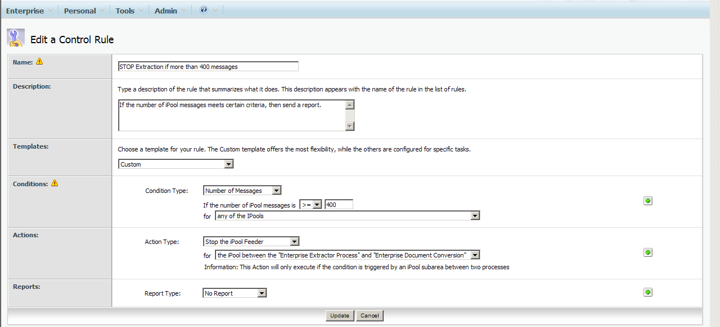
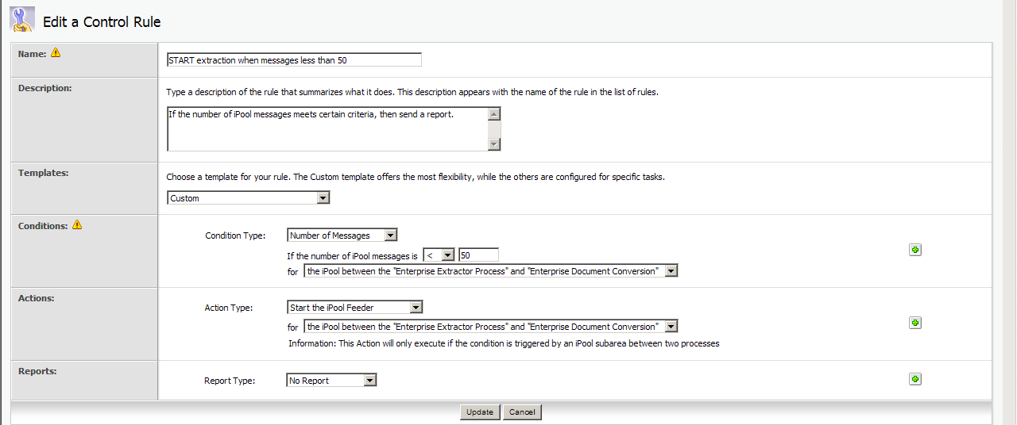
Set a rule to restart document conversion if it hits a “non-data” error
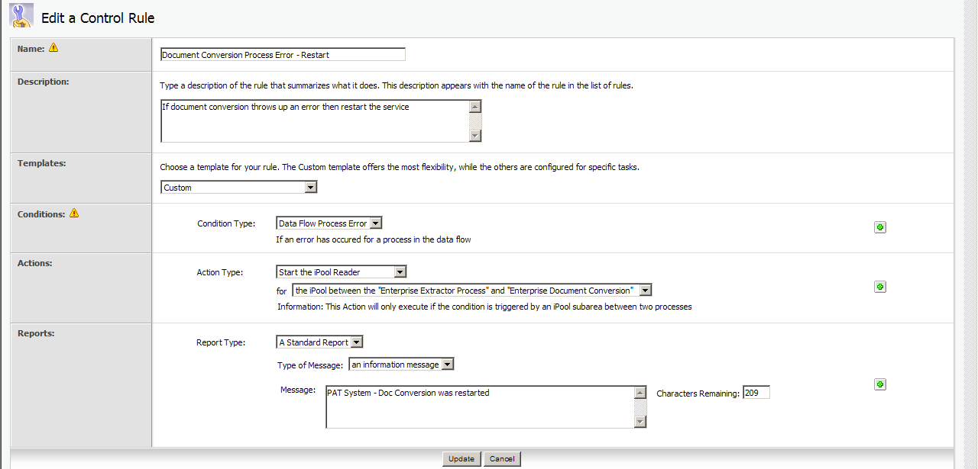
Connect the additional front end
Install Elink server  See APPENDIX D | Test and change elink email address to production one
Configure elink module:
?func=admin.eLinkConfigure&nextURL=

if Exchange Server relay test email address is available, configure redirect
Recycle Bin Configuration
- Set all objects to recycle
- Enable both menu items and retain original permissions
- Set agent to purge deleted documents after 60 days
Classification Configuration – checked managed objects are set correctly, this will affect permissions inheritance. The following subtypes should be managed 0,144,145,557,136,749 | Align opentext.ini file
Set agent the following agent to run of their own thread (DS, elink, recycle )
APPENDIX D
Configure Esign – setup mimetype settings as per below  See APPENDIX F  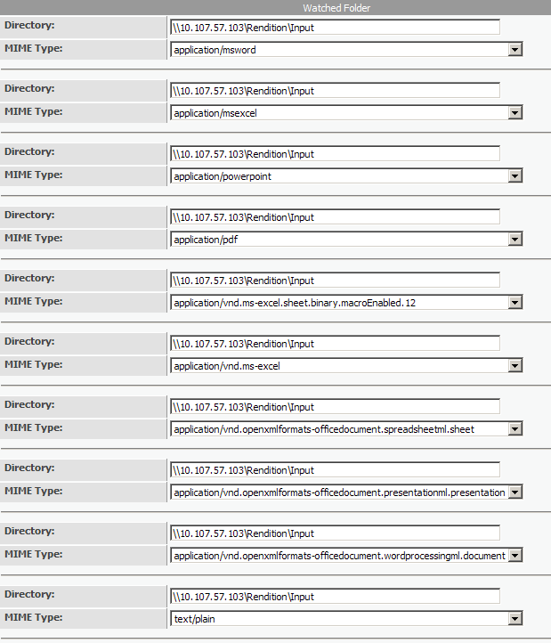  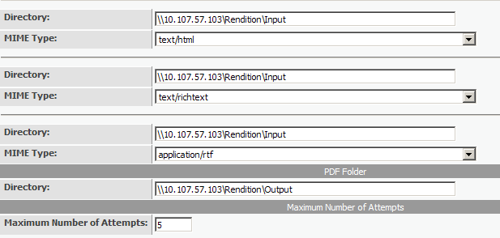 | Align esign section on every FE.
Configure the recovery tab of the CSServer and Admin Server to restart the service after failure.

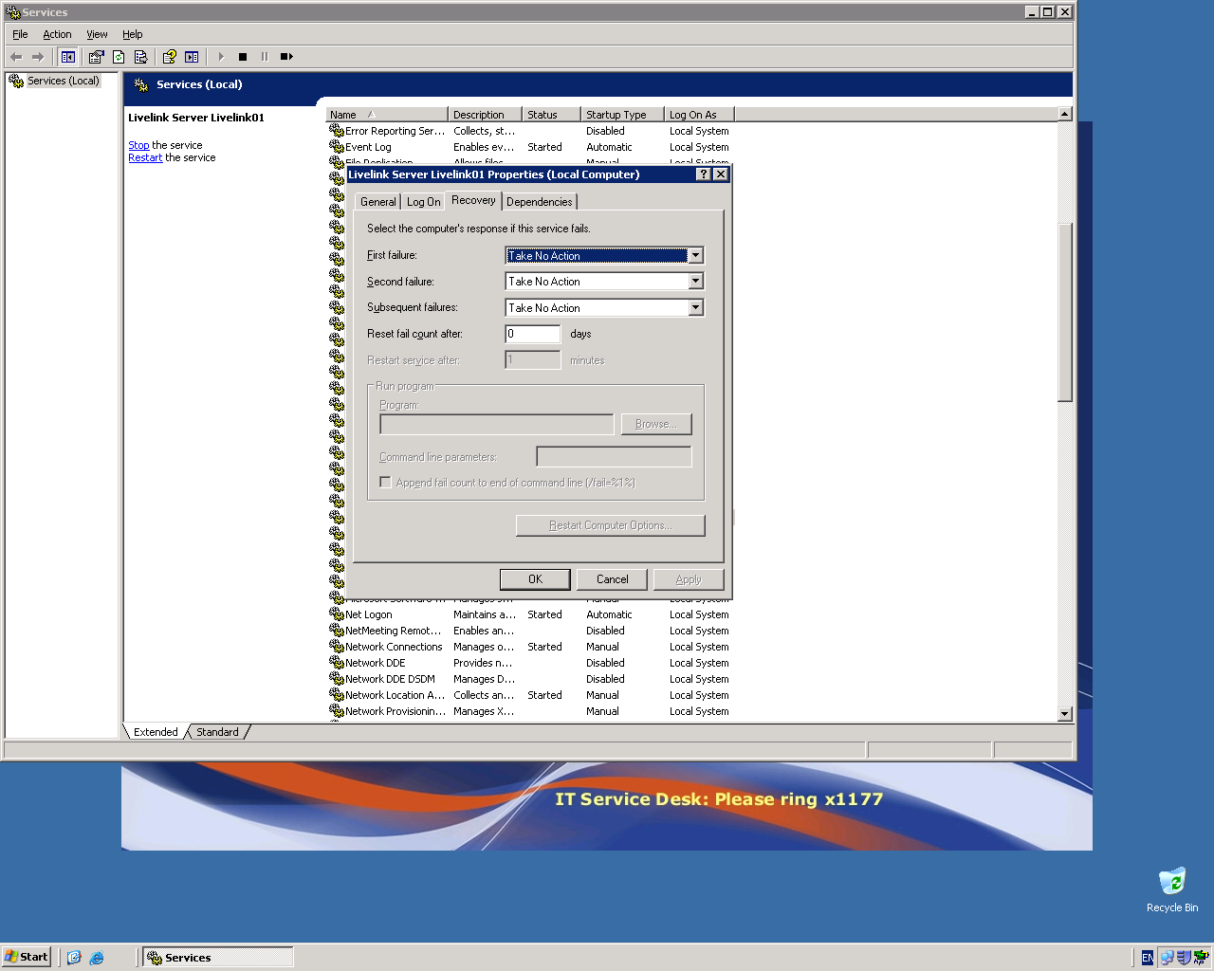

Configure the url redirection
Run DB stats : EXEC dbms_stats.gather_schema_stats('LLMAINP', cascade=>TRUE); | SYS Admin
Configure Rendition folder APPENDIX S
Configure the Multi-File Output Administration APPENDIX T

?func=multifile.settings

Configure Electronic Signatures Robot ?func=fdaadmin.setdirectories
General Configuration of Force-Prets GED Interface: ?func=forcepretsgedinterfaceadmin.generalsettings
Configure General Configuration of GED MultiAgent
func=saweibmultiagent.generalsettings

Log Directory: //cl13-pbs-eib.beilux.eib.org/e$/data/common/multiagent

EAI define document server adress and path: TBA
Define Document command: ./jre/bin/java -jar ./module/saweibmultiagent_10_5_1/ojlib/ePsWs1.jar %1 %2 %3 "%4" "%5" >>../logs/multiagent.log

func=saweibmultiagent.generalsettings&agentId=220248
func=saweibmultiagent.generalsettings&agentId=220250

Configure GED PDF Conversion Administration
func=saweibconverttopdf.configurepdf

GED MultiAgent
Add a secondary extractor
C:\Users\ble\Desktop\Admin\upgrade\Search_Indexing

Run MOD.SQL to update DATAID to NUMBER(19,0) in custom table that contain the DATAID as coloumn.
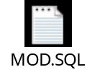
System testing

APPENDIX A

CS PROD database user schema changes

Do not drop these tables as they related to the following views DAUDITMOREVIEW, DAUDITVIEW

drop table DAUDITMORE_2014 cascade constraints;
drop table DAUDITMORE_2013 cascade constraints;
drop table DAUDITMORE_2012 cascade constraints;
drop table DAUDITMORE_2011 cascade constraints;
drop table DAUDITMORE_2010 cascade constraints;
drop table DAUDITMORE_2009 cascade constraints;
drop table DAUDITMORE_2008 cascade constraints;
drop table DAUDITMORE_2007 cascade constraints;
drop table DAUDITMORE_2006 cascade constraints;
drop table DAUDITMORE_2005 cascade constraints;
drop table DAUDITMORE_2004 cascade constraints;
drop table DAUDITMORE_2003 cascade constraints;

drop table DAUDITNEW_2014 cascade constraints;
drop table DAUDITNEW_2013 cascade constraints;
drop table DAUDITNEW_2012 cascade constraints;
drop table DAUDITNEW_2011 cascade constraints;
drop table DAUDITNEW_2010 cascade constraints;
drop table DAUDITNEW_2009 cascade constraints;
drop table DAUDITNEW_2008 cascade constraints;
drop table DAUDITNEW_2007 cascade constraints;
drop table DAUDITNEW_2006 cascade constraints;
drop table DAUDITNEW_2005 cascade constraints;
drop table DAUDITNEW_2004 cascade constraints;
drop table DAUDITNEW_2003 cascade constraints;

drop table KUAF_20140515_1941 cascade constraints;
drop table KUAF_20140515_1941 cascade constraints;

alter table DTREE set unused column <column name>;

alter table DTREE drop unused columns;

APPENDIX B

Form Templates db upgrade

TO DO Before intermediate backup of the db
Background info
From function menu→ propriety→ specific will display table link to form template.
To verify the template
function menu→ manage relational table→ verify table schema
when trying to delete a template check to make sure that not view is locked
After deleting a form template make sure to drop the linked table on the database.
Form upgrade
Retrieve all form templates
- Select * from dtree where subtype=230
For each template
- check if template is linked to a table,
- check if the linked table has an IterationNum column, if not alter table
alter table ...
add IterationNum number(10)
default 1 not null;
- check if templates containing multiline (comment) attribute display correctly, if not
  - delete and recreate multiline attribute in the template or
  - delete template

APPENDIX C

Index all from pre-prod db backup date

Replace '30/05/2016 19:00:00' in the following statement with pre-prod db backup date
Run the statement with the correct date.
INSERT INTO DTreeNotify( NID, NType, DataID,
VersionNum, OwnerID, Subtype )
SELECT DTreeNotifySequence.NextVal, 1,
DataID, VersionNum, OwnerId, Subtype
FROM DTree
WHERE ModifyDate >= to_date('dateNow
)

Eg:
INSERT INTO DTreeNotify( NID, NType, DataID,
VersionNum, OwnerID, Subtype )
SELECT DTreeNotifySequence.NextVal, 1,
DataID, VersionNum, OwnerId, Subtype
FROM DTree
WHERE ModifyDate >= to_date('30/05/2016 19:00:00' ,
'dd/mm/yyyy hh24:mi:ss')

APPENDIX D

Elink configuration on the cluster

Admin server:
[options]
maxRightsString=250
MaxOpenSessions=100
wantByteServing=FALSE
wantLogs=FALSE
#wantLogs=FALSE
wantSecureCookies=TRUE
wantTimings=TRUE
wantVerbose=TRUE
wantWeb=TRUE
EnableAgents=TRUE
EnableAgentsTrace=FALSE
EnableAgentsTestAll=FALSE
EnableNotification=TRUE
wantSearch=TRUE
wantSearchLogs=TRUE
wantDebugSearch=TRUE
wantSearchLogs=FALSE
wantHTMLView=TRUE
ObjectRankEnabled=TRUE
categoryNumToUpgrade=200
errorMessageWantDebugInfo=FALSE
wantIcons=TRUE
wantSummaryTimings=TRUE

[scheduleactivity]
1000=1
1964=1
4000=1
4100=0
4101=0
4102=0
8900=1
8999=1
9000=1
9001=1
3502=1
8000=0
2501=1
2502=1
2503=1
2504=1
2001=0
2001=0
2002=0
2003=1
2004=1
2005=1
3001=0
3601=1
8010=1
3504=1
9001_Instances=1
9001_SeparateAdmin=false
9101=1
20201=1
20200=1
220250=1
20029=1
20023=0
27247=1

[loader]
load=sockserv;agents;notify;wfagent;spchange;RecyclebinAgent;Agent4EIFinvoices;wrscheduleagent;wrcollectionagent;EIB_Upload_Folder_Agent;processPdfAgent
#load=sockserv;;wrscheduleagent;wrcollectionagent
load_relagent=relagent
load_distributedagent=distributedagent
load_daagent=daagent
load_verify=verifyAgent

[eLink]
debug=0
format=text/html
send_my_own=true
virtualHostname=ged105.eib.org
pop3MaxMessagesPerSession=500
pop3Password=bGl2ZWxpbmsA
pop3Port=110
pop3Server=cl13-pbs-eib
pop3Username=elink
smtpPort=25
smtpServer=cl13-pbs-eib
tempDir=eLinkTemp
timeout=5
maxOutboundAttachmentSize=1024000
restrictedList={'mailer-daemon@','postmaster@','daemon@'}
restrictedXHeader={'X-On-Vacation'}
restrictedSubject={''}
allowedDomains={''}
restrictedTypes={'vcf'}
newStyleEmail=false
AllowAnonTopicReply=true
AllowAllUsersPostTopicReply=true
AttachmentLinkCmd=open
EnableEmailDocLink=false
InboundDocAcknowledgement=true
CancelAllowed=true
ExpandAutoSubscribedGroups=false
MyMailEnabled=false
LastTestMessage=Test message sent at 2016-Oct-05 16:52
maxInboundMailSize=1024000
SMTPDebug=TRUE

Front End:
[options]
categoryNumToUpgrade=200
EnableAgents=TRUE
EnableAgentsTestAll=FALSE
EnableAgentsTrace=FALSE
EnableNotification=TRUE
errorMessageWantDebugInfo=FALSE
MaxOpenSessions=100
maxRightsString=250
ObjectRankEnabled=TRUE
wantByteServing=FALSE
wantHTMLView=TRUE
wantIcons=TRUE
wantLapiTrace=FALSE
wantLogs=false
wantSearch=TRUE
wantSearchLogs=FALSE
wantSecureCookies=TRUE
wantTimings=TRUE
wantVerbose=TRUE
wantWeb=TRUE
wantdebugsearch=
wantSummaryTimings=TRUE
WantDirectFetch=false

[scheduleactivity]
1000=1
2001=1
2501=1
2502=1
2503=1
2504=1
3502=1
3601=1
4000=1
4100=0
4101=0
4102=0
8000=0
8010=0
8900=1
8999=1
9000=1
9001=1
3501=1
3504=1
9001_Instances=1
9001_SeparateAdmin=false
9101=1
9102=0
20029=0
20031=0
220249=0

[loader]
load=sockserv
#load=sockserv;agents;notify;wfagent;spchange;RecyclebinAgent;Agent4EIFinvoices;wrscheduleagent;wrcollectionagent;processPdfAgent
#load=sockserv;;wrscheduleagent;wrcollectionagent
#load_relagent=relagent
#load_distributedagent=distributedagent
#load_daagent=daagent
#load_verify=verifyAgent

APPENDIX E

Configuring eSign in a Clustered Environment
The eSign module uses third-party executables from Appligent Inc. to securely sign and watermark documents within an Enterprise Server workflow. These command-line tools perform a specific function or extract particular information from PDF files. They run as a process on the primary CSAdmin service installed with Enterprise Server.
When you run eSign in a clustered environment, an Admin server must be present, started, and local to each Enterprise Server instance in the cluster.
Typically, in a cluster configuration, indexing and search run on a computer located outside the cluster that does not accept user requests. (In other words, users never directly access the indexing and search computer with general Enterprise Server requests.) The CSServer service on this box is typically disabled, and only the CSAdmin service runs. Open Text refers to this special indexing and search computer as the "default Admin server."
However, even when Enterprise Server runs with a separate Admin server for indexing and searching, eSign requires an Admin server to be present, started, and local on each Enterprise Server front-end computer to run the PDF manipulation process. To fulfill this requirement, complete the following steps:
1. On each front-end Enterprise Server instance, in addition to the CSServer service, ensure that the CSAdmin service is also running.
2. On each front-end Enterprise Server instance, follow the steps below to add an Admin server:
a) On the CSAdministration page, click Search Administration > Open the System Object Volume. On the System Object Volume page, click Add Item > Admin Server, and specify the following:
Alias Name: eSignAdminServerX
Replace X with 1 for the first front-end server, 2 for the second front-end server, and so on. However, the name does not have to follow this format. You can use any name you want for the Alias Name.
Make Default Server:
Leave this option disabled.
Host Name:
Enter the host name of this particular computer.
Port Number:
Use the "port" value from the [OTAdmin] section of the opentext.ini file on this particular computer. (The OTAdmin port for the computer specified in "Host Name" above.)
Password: CS
Verify Password: CS
NOTE: You must use the password "livelink" (without the quotation marks).
b) Click Add Item.
c) Ensure that the status of the "eSignAdminServerX" you just defined is Active. If it is not, click the Functions menu for "eSignAdminServerX," and then click Ping.
3. Because agents need to run only on the back-end server, configure the opentext.ini file as follows on each front-end instance:
[options]
EnableAgents=TRUE
[loader]
load=sockserv;javaserver;agents
[scheduleactivity]
2504=0
2503=0
2502=0
2501=0
9001_SeparateAdmin=false
9001_Instances=0
1000=0
4000=0
4100=0
4101=0
4102=0
8900=0
8999=0
9000=0
9001=0
3502=0
8000=0
2990=0
2991=0
2992=0
5858=0 (add this to turn off recommender agent on the other systems)

Add the following section to the opentext.ini file of all Front End Servers
[esign]
PreSetUserName=true
SigningTZone=server
WorkingDir=D:\apps\OTCS01\module\esign_10_0_0\ProcessFiles\
SysAdminSign=false
SignPerPage=5
InitSignCheck=false
TimeZone=GMT Daylight Time
NextVersionDir_1=1
VersionDirs_1_1='\\\\Admin Server TBA\\Rendition\\Input'
VersionTypes_1_1='application/msword'
NextVersionDir_2=1
VersionDirs_2_1='\\\\Admin Server TBA\\Rendition\\Input'
VersionTypes_2_1='application/msexcel'
NextVersionDir_3=1
VersionDirs_3_1='\\\\Admin Server TBA\\Rendition\\Input'
VersionTypes_3_1='application/powerpoint'
NextVersionDir_4=1
VersionDirs_4_1='\\\\Admin Server TBA\\Rendition\\Input'
VersionTypes_4_1='application/pdf'
NextVersionDir_5=1
VersionDirs_5_1='\\\\Admin Server TBA\\Rendition\\Input'
VersionTypes_5_1='application/vnd.ms-excel.sheet.binary.macroEnabled.12'
NextVersionDir_6=1
VersionDirs_6_1='\\\\Admin Server TBA\\Rendition\\Input'
VersionTypes_6_1='application/vnd.ms-excel'
NextVersionDir_7=1
VersionDirs_7_1='\\\\Admin Server TBA\\Rendition\\Input'
VersionTypes_7_1='application/vnd.openxmlformats-officedocument.spreadsheetml.sheet'
NextVersionDir_8=1
VersionDirs_8_1='\\\\Admin Server TBA\\Rendition\\Input'
VersionTypes_8_1='application/vnd.openxmlformats-officedocument.presentationml.presentation'
NextVersionDir_9=1
VersionDirs_9_1='\\\\Admin Server TBA\\Rendition\\Input'
VersionTypes_9_1='application/vnd.openxmlformats-officedocument.wordprocessingml.document'
NextVersionDir_10=1
VersionDirs_10_1='\\\\Admin Server TBA\\Rendition\\Input'
VersionTypes_10_1='text/plain'
NextVersionDir_11=1
VersionDirs_11_1='\\\\Admin Server TBA\\Rendition\\Input'
VersionTypes_11_1='text/html'
NextVersionDir_12=1
VersionDirs_12_1='\\\\Admin Server TBA\\Rendition\\Input'
VersionTypes_12_1='text/richtext'
NextVersionDir_13=1
VersionDirs_13_1='\\\\Admin Server TBA\\Rendition\\Input'
VersionTypes_13_1='application/rtf'
MaxAttempts=5
RendDir=\\Admin Server TBA\Rendition\Output

APPENDIX F

To remove all Admin servers and related entries from a CSinstance

delete from kini where inisection = 'AdminServers';
delete from kini where inisection='SliceReferences';
delete from kini where inisection='UniqueSliceReference';
delete from kini where inisection = 'LivelinkExtractor';

delete from dtreeacl where dataid in (select dataid from dtree where name like 'Enterprise%' and name not like 'Slice Folder' and ParentID!=-1 and ownerID=-2001);

delete from DTreeAncestors where dataid in (select dataid from dtree where name like 'Enterprise%' and name not like 'Slice Folder' and ParentID!=-1 and ownerID=-2001);

delete from ProviderData where providerid in (select dataid from dtree where name like 'Enterprise%' and name not like 'Slice Folder' and ParentID!=-1 and ownerID=-2001);

delete from DVersData where docid in (select dataid from dtree where name like 'Enterprise%' and name not like 'Slice Folder' and ParentID!=-1 and ownerID=-2001);

delete from SOVControlRules where DataID in (select dataid from dtree where name like 'Enterprise%' and name not like 'Slice Folder' and ParentID!=-1 and ownerID=-2001);

delete from dtreeacl where dataid in (select dataid from dtree where name like 'Help%' and name not like 'Slice Folder' and ParentID!=-1 and ownerID=-2001);

delete from DTreeAncestors where dataid in (select dataid from dtree where name like 'Help%' and name not like 'Slice Folder' and ParentID!=-1 and ownerID=-2001);

delete from ProviderData where providerid in (select dataid from dtree where name like 'Help%' and name not like 'Slice Folder' and ParentID!=-1 and ownerID=-2001);

delete from DVersData where docid in (select dataid from dtree where name like 'Help%' and name not like 'Slice Folder' and ParentID!=-1 and ownerID=-2001);

delete from dtreeacl where dataid in (select dataid from dtree where name like 'Admin Help%' and name not like 'Slice Folder' and ParentID!=-1 and ownerID=-2001);

delete from DTreeAncestors where dataid in (select dataid from dtree where name like 'Admin Help%' and name not like 'Slice Folder' and ParentID!=-1 and ownerID=-2001);

delete from ProviderData where providerid in (select dataid from dtree where name like 'Admin Help%' and name not like 'Slice Folder' and ParentID!=-1 and ownerID=-2001);
delete from DVersData where docid in (select dataid from dtree where name like 'Admin Help%' and name not like 'Slice Folder' and ParentID!=-1 and ownerID=-2001);

delete from dtreeacl where dataid in (select dataid from dtree where name like 'Partition%' and name not like 'Slice Folder' and ParentID!=-1 and ownerID=-2001);
delete from DTreeAncestors where dataid in (select dataid from dtree where name like 'Partition%' and name not like 'Slice Folder' and ParentID!=-1 and ownerID=-2001);
delete from ProviderData where providerid in (select dataid from dtree where name like 'Partition%' and name not like 'Slice Folder' and ParentID!=-1 and ownerID=-2001);
delete from DVersData where docid in (select dataid from dtree where name like 'Partition%' and name not like 'Slice Folder' and ParentID!=-1 and ownerID=-2001);
delete from dtreeacl where dataid in (select dataid from dtree where name like 'Prospector%' and name not like 'Slice Folder' and ParentID!=-1 and ownerID=-2001);
delete from DTreeAncestors where dataid in (select dataid from dtree where name like 'Prospector%' and name not like 'Slice Folder' and ParentID!=-1 and ownerID=-2001);
delete from ProviderData where providerid in (select dataid from dtree where name like 'Prospector%' and name not like 'Slice Folder' and ParentID!=-1 and ownerID=-2001);
delete from DVersData where docid in (select dataid from dtree where name like 'Prospector%' and name not like 'Slice Folder' and ParentID!=-1 and ownerID=-2001);
delete from dtreeacl where dataid in (select dataid from dtree where name like '%Classification Importer%' and name not like 'Slice Folder' and ParentID!=-1 and ownerID=-2001);
delete from DTreeAncestors where dataid in (select dataid from dtree where name like '%Classification Importer%' and name not like 'Slice Folder' and ParentID!=-1 and ownerID=-2001);
delete from ProviderData where providerid in (select dataid from dtree where name like '%Classification Importer%' and name not like 'Slice Folder' and ParentID!=-1 and ownerID=-2001);
delete from DVersData where docid in (select dataid from dtree where name like '%Classification Importer%' and name not like 'Slice Folder' and ParentID!=-1 and ownerID=-2001);
delete from kini where inisection='OTIndex';
delete from kini where inisection='IndexObject';

delete from dtree where name like 'Enterprise%' and OwnerID=-2001;

delete from dtree where name like 'Best Bets%' and ownerid=-2001;
delete from dtree where name like 'Help%' and OwnerID=-2001;
delete from dtree where name like 'Admin Help%' and OwnerID=-2001;
delete from dtree where name like 'Partition%' and OwnerID=-2001;
delete from dtree where name like 'Prospector%' and ownerid=-2001;
delete from dtree where name like '%Classification Importer%' and ownerid=-2001;

(To include Backup Manager:

select name, dataid from dtree where name like '%Backup %' and OwnerID=-2001)
delete from DVersData where docid in (select dataid from dtree where name like '%Backup Process Partition%' and ownerid=-2001);
delete from dtreeacl where dataid in (select dataid from dtree where name like '%Backup Process Partition%' and ownerid=-2001);
delete from DTreeAncestors where dataid in (select dataid from dtree where name like '%Backup Process Partition%' and ownerid=-2001);
delete from ProviderData where providerid in (select dataid from dtree where name like '%Backup Process Partition%' and ownerid=-2001);
delete from dtree where name like '%Backup Process Partition%' and ownerid=-2001;

select * from LLSystemData where section='IndexObject';

delete from LLSystemData where section='IndexObject';
update dtree set childcount = 0 where name like 'Slice Folder';

This section must be run after the above has been committed to re-create the server keys to point to the new Admin server, without it subsequent index creation will fail

insert into kini (inisection, inikeyword, inivalue) values ('AdminServers', 'keys', '''Default''');

insert into kini (inisection, inikeyword, inivalue) values ('AdminServers','Default','''WINDOWS,DEFAULT,CL13-PBS-EIB,5858,Admin,bGl2ZWxpbmsA,0''');

commit;

APPENDIX G

Content Server 10.5 Instance install guide

https://ged.beilux.eib.org/ged/ged.dll/open/66734917

APPENDIX H

Backup Manager scheduling
Get the dataid for the backup manager

Then change the dataid in the statement below

select name,subtype,dataid, extendeddata
from dtree
where dataid in (select dataid
from dtree
where parentid =<Dataid of the back manager>)

Run the sql in a livereport set to auto-livereport format

This will give extended data for the backup processes. The backup manager processes should be running on the same server which owns the partitions.

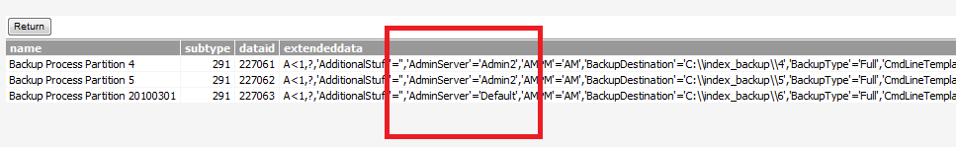

You can then change the time that the schedule is set to run, thus staggering them.

Load-Balancer configuration
200 is the expected code back.

Replacing based keep-alive scripts on each front-end server
After setting the Keep-alive script to ?func=ll.index
Set Services to restart automatically

APPENDIX I

Add Storage Providers

Run the script:

SET DEFINE OFF;
--
--SQL Statement which produced this data:
SELECT ROWID, K.INISECTION, K.INIKEYWORD, K.INIVALUE
FROM KINI K
Where
(INIKEYWORD LIKE 'Default' or INIKEYWORD like 'MVPVolume%') and inisection like '%LogicalProviders'

ROWID INISECTION INIKEYWORD INIVALUE
AAADYDAAXAAA25GAAS Livelink.LogicalProviders Default {'ExtShared','\\\\CL08-PBS-EIB\\i$\\DATA-1-T1\\'}
AAADYDAAXAAA25GAAS Livelink.DocStorage Default {'ExtShared','\\\\CL08-PBS-EIB\\i$\\DATA-1-T1\\'}
AAADYDAAXAAA25WAAh Livelink.LogicalProviders MVPVolume10 {'ExtShared','\\\\CL08-PBS-EIB\\i$\\DATA-1-T1\\'}
AAADYDAAXAAA25VAAb Livelink.LogicalProviders MVPVolume11 {'ExtShared','\\\\CL08-PBS-EIB\\i$\\DATA-2-T1\\'}
AAADYDAAXAAA25XAAB Livelink.LogicalProviders MVPVolume12 {'ExtShared','\\\\CL08-PBS-EIB\\i$\\DATA-3-T1\\'}
AAADYDAAXAAA25WAAY Livelink.LogicalProviders MVPVolume13 {'ExtShared','\\\\CL08-PBS-EIB\\i$\\DATA-4-T1\\'}
AAADYDAAXAAA25fAAQ Livelink.LogicalProviders MVPVolume14 {'ExtShared','\\\\CL08-PBS-EIB\\i$\\DATA-5-T1\\'}
AAADYDAAbAACQCNAAA Livelink.LogicalProviders MVPVolume15 {'ExtShared','\\\\CL08-PBS-EIB\\i$\\DATA-6-T1\\'}
AAADYDAAXAAA25WAAZ Livelink.LogicalProviders MVPVolume20 {'ExtShared','\\\\CL08-PBS-EIB\\i$\\DATA-1-T3\\'}
AAADYDAAXAAA25XAAA Livelink.LogicalProviders MVPVolume21 {'ExtShared','\\\\CL08-PBS-EIB\\i$\\DATA-2-T3\\'}
AAADYDAAXAAA25VAAc Livelink.LogicalProviders MVPVolume22 {'ExtShared','\\\\CL08-PBS-EIB\\i$\\DATA-3-T3\\'}
AAADYDAAXAAA25IAAF Livelink.LogicalProviders MVPVolume23 {'ExtShared','\\\\CL08-PBS-EIB\\i$\\DATA-4-T3\\'}
AAADYDAAXAAA25cAAS Livelink.LogicalProviders MVPVolume24 {'ExtShared','\\\\CL08-PBS-EIB\\i$\\DATA-5-T3\\'}
AAADYDAAbAACQCOAAE Livelink.LogicalProviders MVPVolume25 {'ExtShared','\\\\CL08-PBS-EIB\\i$\\DATA-6-T3\\'}
AAADYDAAbAACQCLAAa Livelink.LogicalProviders MVPVolume30 {'ExtShared','\\\\CL08-PBS-EIB\\i$\\DATA-7-T1\\'}
AAADYDAAXAAA25eAAQ Livelink.LogicalProviders MVPVolume31 {'ExtShared','\\\\CL08-PBS-EIB\\i$\\DATA-7-T3\\'}

Insert into KINI
(INISECTION, INIKEYWORD, INIVALUE)
Values
('Livelink.LogicalProviders', 'Default', '{''EXTSHARED'',''\\\\Vmd-ged105-02\\DATA-1-T1\\''}');

Insert into KINI
(INISECTION, INIKEYWORD, INIVALUE)
Values
('Livelink.LogicalProviders', 'MVPVolume23', '{''ExtShared'',''\\\\Vmd-ged105-02\\DATA-4-T3\\''}');

Insert into KINI
(INISECTION, INIKEYWORD, INIVALUE)
Values
('Livelink.LogicalProviders', 'MVPVolume11', '{''ExtShared'',''\\\\Vmd-ged105-02\\DATA-2-T1\\''}');

Insert into KINI
(INISECTION, INIKEYWORD, INIVALUE)
Values
('Livelink.LogicalProviders', 'MVPVolume22', '{''ExtShared'',''\\\\Vmd-ged105-02\\DATA-3-T3\\''}');

Insert into KINI
(INISECTION, INIKEYWORD, INIVALUE)
Values
('Livelink.LogicalProviders', 'MVPVolume13', '{''ExtShared'',''\\\\Vmd-ged105-02\\DATA-4-T1\\''}');

Insert into KINI
(INISECTION, INIKEYWORD, INIVALUE)
Values
('Livelink.LogicalProviders', 'MVPVolume20', '{''ExtShared'',''\\\\Vmd-ged105-02\\DATA-1-T3\\''}');

Insert into KINI
(INISECTION, INIKEYWORD, INIVALUE)
Values
('Livelink.LogicalProviders', 'MVPVolume10', '{''ExtShared'',''\\\\Vmd-ged105-02\\DATA-1-T1\\''}');

Insert into KINI
(INISECTION, INIKEYWORD, INIVALUE)
Values
('Livelink.LogicalProviders', 'MVPVolume21', '{''ExtShared'',''\\\\Vmd-ged105-02\\DATA-2-T3\\''}');

Insert into KINI
(INISECTION, INIKEYWORD, INIVALUE)
Values
('Livelink.LogicalProviders', 'MVPVolume12', '{''ExtShared'',''\\\\Vmd-ged105-02\\DATA-3-T1\\''}');

Insert into KINI
(INISECTION, INIKEYWORD, INIVALUE)
Values
('Livelink.LogicalProviders', 'MVPVolume24', '{''ExtShared'',''\\\\Vmd-ged105-02\\DATA-5-T3\\''}');

Insert into KINI
(INISECTION, INIKEYWORD, INIVALUE)
Values
('Livelink.LogicalProviders', 'MVPVolume31', '{''ExtShared'',''\\\\Vmd-ged105-02\\DATA-7-T3\\''}');

Insert into KINI
(INISECTION, INIKEYWORD, INIVALUE)
Values
('Livelink.LogicalProviders', 'MVPVolume14', '{''ExtShared'',''\\\\Vmd-ged105-02\\DATA-5-T1\\''}');

Insert into KINI
(INISECTION, INIKEYWORD, INIVALUE)
Values
('Livelink.LogicalProviders', 'MVPVolume30', '{''ExtShared'',''\\\\Vmd-ged105-02\\DATA-7-T1\\''}');

Insert into KINI
(INISECTION, INIKEYWORD, INIVALUE)
Values
('Livelink.LogicalProviders', 'MVPVolume15', '{''ExtShared'',''\\\\Vmd-ged105-02\\DATA-6-T1\\''}');

Insert into KINI
(INISECTION, INIKEYWORD, INIVALUE)
Values
('Livelink.LogicalProviders', 'MVPVolume25', '{''ExtShared'',''\\\\Vmd-ged105-02\\DATA-6-T3\\''}');

update kini set inivalue='{''ExtShared'',''\\\\Vmd-ged105-02\\DATA-1-T1\\''}' where inisection = 'Livelink.LogicalProviders' AND iniKeyword='Default';
update kini set inivalue='{''ExtShared'',''\\\\CL08-PBS-EIB\\i$\\DATA-1-T1\\''}' where inisection = 'Livelink.LogicalProviders' AND iniKeyword='MVPVolume10';
update kini set inivalue='{''ExtShared'',''\\\\CL08-PBS-EIB\\i$\\DATA-2-T1\\''}' where inisection = 'Livelink.LogicalProviders' AND iniKeyword='MVPVolume11';
update kini set inivalue='{''ExtShared'',''\\\\CL08-PBS-EIB\\i$\\DATA-3-T1\\''}' where inisection = 'Livelink.LogicalProviders' AND iniKeyword='MVPVolume12';
update kini set inivalue='{''ExtShared'',''\\\\CL08-PBS-EIB\\i$\\DATA-4-T1\\''}' where inisection = 'Livelink.LogicalProviders' AND iniKeyword='MVPVolume13';
update kini set inivalue='{''ExtShared'',''\\\\CL08-PBS-EIB\\i$\\DATA-1-T3\\''}' where inisection = 'Livelink.LogicalProviders' AND iniKeyword='MVPVolume14';
update kini set inivalue='{''ExtShared'',''\\\\Vmd-ged105-02\\DATA-6-T1\\''}' where inisection = 'Livelink.LogicalProviders' AND iniKeyword='MVPVolume15';
update kini set inivalue='{''ExtShared'',''\\\\CL08-PBS-EIB\\i$\\DATA-3-T3\\''}' where inisection = 'Livelink.LogicalProviders' AND iniKeyword='MVPVolume20';
update kini set inivalue='{''ExtShared'',''\\\\CL08-PBS-EIB\\i$\\DATA-4-T1\\''}' where inisection = 'Livelink.LogicalProviders' AND iniKeyword='MVPVolume21';
update kini set inivalue='{''ExtShared'',''\\\\CL08-PBS-EIB\\i$\\DATA-1-T3\\''}' where inisection = 'Livelink.LogicalProviders' AND iniKeyword='MVPVolume22';
update kini set inivalue='{''ExtShared'',''\\\\CL08-PBS-EIB\\i$\\DATA-2-T3\\''}' where inisection = 'Livelink.LogicalProviders' AND iniKeyword='MVPVolume23';
update kini set inivalue='{''ExtShared'',''\\\\CL08-PBS-EIB\\i$\\DATA-3-T3\\''}' where inisection = 'Livelink.LogicalProviders' AND iniKeyword='MVPVolume24';
update kini set inivalue='{''ExtShared'',''\\\\Vmd-ged105-02\\DATA-6-T3\\''}' where inisection = 'Livelink.LogicalProviders' AND iniKeyword='MVPVolume25';

update kini set inivalue = '{''https://ged.beilux.eib.org/ged/ged.dll''}' where inisection = 'Livelink.WebInfo' and inikeyword = 'URL';
commit;

COMMIT;

Check the KINI table

SELECT ROWID, K.INISECTION, K.INIKEYWORD, K.INIVALUE
FROM KINI K
Where
(INIKEYWORD LIKE 'Default' or INIKEYWORD like 'MVPVolume%') and inisection like '%LogicalProviders'

APPENDIX J
TBA

APPENDIX K

Set agent to run off their own threads
Directory Services agents (DS)
Determine the related agent and the agent id you would like for them to run off their own threads.
In this example we are going to configure the Directory service agent to run off their own thread.
DS have several agents from fronm 2002 to 2020;
we are going to use agent 2002,2003,2004,2005
- Create the agent thread as below with desire name
[diragents]
lib=.\bin\lljob.dll
name=lljob
prio=critical
timeout=5000
info=.\config\opentext.ini;diragents
StartScript=.\scripts\llfull.lxe
JobScript=.\scripts\agent_run.e
SleepIntervalSec=300
ActivityIDs=2002,2003,2004,2005
- Add the agentid the exclude activies for agents section as below
[agents]
ExcludeActivityIDs=2002,2003,2004,2005
- Add to the loader section the new agent name as below
[loader]
load=diragents
- Enable the agent id in the agent schedule as below
[scheduleactivity]
2002=1
2003=1
2004=1
2005=1

APPENDIX M

Uninstall modules that can’t be upgraded or are no longer required

Explorer Module:
The Explore module has 3 components that will need to be uninstall: webexp, otemailexp and exppro
- Remove kini entrees related to Explorer Module
Select * from kini where inisection='Module.VersionInfo' and inikeyword in ('Webexp','otemailexp')
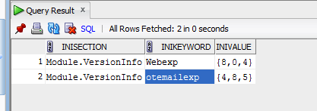
Delete from kini where inisection='Module.VersionInfo' and inikeyword in ('Webexp','otemailexp')
- Remove the entrees below from the [Modules] section in the opentext.ini
module_70=webexp
module_71=exppro
module_72=otemailexp
ospaces_otemailexp={'otemailexp'}
ospaces_webexp={'webexp'}
ospaces_exppro={'exppro'}
otemailexp=_10_0_0
webexp=_10_0_0
exppro=_10_0_0
- Reset the module sequence number in the [Modules] section to reflate the above changes
- Remove any explorer related section from the opent.ini
[ClientDownload], [Explorer], [ExplorerAuthentication], [WebExplorerOptions], [otemailexp], [ExplorerVolRoots]

APPENDIX N: Disabling and Enabling Appearances
480 Appearances
482 Global Appearances

- Find all the appearances dataid that are enable (status=1)
Select dataid, name, status from dtree where subtype in (480, 482)

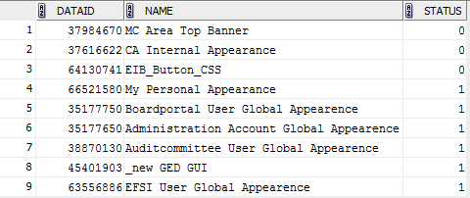

37984670 MC Area Top Banner 0
37616622 CA Internal Appearance 0
64130741 EIB_Button_CSS 0
35177750 Boardportal User Global Appearence 1
66521580 My Personal Appearance 1
35177650 Administration Account Global Appearence 1
38870130 Auditcommittee User Global Appearence 1
45401903 _new GED GUI 1
63556886 EFSI User Global Appearence 1

- Disable the appearances
Update dtree set status=0 where dataid in (select dataid from dtree where subtype in (480,482) and status=1)

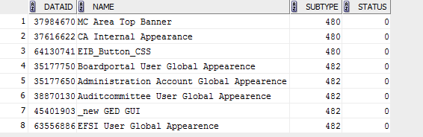

- Enable the appearances
update dtree set status=1 where dataid=<appearance dataid>

update dtree set status=1 where dataid=66521580;
update dtree set status=1 where dataid=35177750;
update dtree set status=1 where dataid=35177650;
update dtree set status=1 where dataid=38870130;
update dtree set status=1 where dataid=45401903;
update dtree set status=1 where dataid=63556886;
commit;

APPENDIX O: Disabling custom column 'WNF_PQPublisher'

Not applicable
482 Global Appearances

- Find custom entry LLSystemData in WNF_PQPublisher'
select Value from LLSystemData where Section='Columns' and Keyword='ViewColumns'
Output:
V{<'name','dataType','sortable','placeholder'>
<'WNF_LastVersionDate',-7,true,false>
<'WNF_attr_39978437_9',-1,true,false>
<'WNF_attr_783807_2',-1,true,false>
<'WNF_attr_39978437_6',-1,true,false>
<'WNF_attr_783807_8',-1,true,false>
<'WNF_attr_39978437_11',-1,true,false>
<'WNF_attr_783778_12',2,true,false>
<'WNF_attr_39978437_4',-1,true,false>
<'WNF_attr_783807_4',2,true,false>
<'WNF_attr_39978437_5',-1,true,false>
<'WND_Owner',2,false,false>
<'WND_CreatedBy',2,false,false>
<'WND_CreateDate',-7,false,false>
<'WND_ModifiedBy',2,false,false>
<'WND_Version',2,false,false>
<'WNF_attr_783822_8',-1,true,false>
<'WNF_attr_783822_3',2,true,false>
<'WNF_attr_50858400_3',-1,true,false>
<'WNF_attr_50858400_4',2,true,false>
<'WNF_PQPublisher',2,true,false>
<'WND_attr_50858400_11',-1,false,false>}
- Update LLSYSTEMDATA
UPDATE LLSYSTEMDATA SET SECTION = 'Columns_', KEYWORD = 'ViewColumns_' WHERE ROWID = 'AAAFj6AAcAAAHHbAAg' AND ORA_ROWSCN = '2097619'
- Insert into LLSYSTEMDATA
INSERT INTO LLSYSTEMDATA (SECTION, KEYWORD, VALUE) VALUES ('Columns', 'ViewColumns', 'V{<''name'',''dataType'',''sortable'',''placeholder''><''WNF_LastVersionDate'',-7,true,false><''WNF_attr_39978437_9'',-1,true,false><''WNF_attr_783807_2'',-1,true,false><''WNF_attr_39978437_6'',-1,true,false><''WNF_attr_783807_8'',-1,true,false><''WNF_attr_39978437_11'',-1,true,false><''WNF_attr_783778_12'',2,true,false><''WNF_attr_39978437_4'',-1,true,false><''WNF_attr_783807_4'',2,true,false><''WNF_attr_39978437_5'',-1,true,false><''WND_Owner'',2,false,false><''WND_CreatedBy'',2,false,false><''WND_CreateDate'',-7,false,false><''WND_ModifiedBy'',2,false,false><''WND_Version'',2,false,false><''WNF_attr_783822_8'',-1,true,false><''WNF_attr_783822_3'',2,true,false><''WNF_attr_50858400_3'',-1,true,false><''WNF_attr_50858400_4'',2,true,false><''WND_attr_50858400_11'',-1,false,false>}')

APPENDIX P: Disabling custom Facet and column (PR Status and PR Publisher)

- Delete from dtree where dataid in (50911487, 50911050, 50911707, 66142121)
- Delete from dtreeacl where dataid in (50911487, 50911050, 50911707, 66142121)
- DROP DFACET_PQPUBLISHER , DFACET_PQSTATUS

APPENDIX Q: Update DAUDITNEW archive tables and view

- Update Table
ALTER TABLE DAUDITNEW_2003 ADD AGENTID NUMBER(19,0);
ALTER TABLE DAUDITNEW_2004 ADD AGENTID NUMBER(19,0);
ALTER TABLE DAUDITNEW_2005 ADD AGENTID NUMBER(19,0);
ALTER TABLE DAUDITNEW_2006 ADD AGENTID NUMBER(19,0);
ALTER TABLE DAUDITNEW_2007 ADD AGENTID NUMBER(19,0);
ALTER TABLE DAUDITNEW_2008 ADD AGENTID NUMBER(19,0);
ALTER TABLE DAUDITNEW_2009 ADD AGENTID NUMBER(19,0);
ALTER TABLE DAUDITNEW_2010 ADD AGENTID NUMBER(19,0);
ALTER TABLE DAUDITNEW_2011 ADD AGENTID NUMBER(19,0);
ALTER TABLE DAUDITNEW_2012 ADD AGENTID NUMBER(19,0);
ALTER TABLE DAUDITNEW_2013 ADD AGENTID NUMBER(19,0);
ALTER TABLE DAUDITNEW_2014 ADD AGENTID NUMBER(19,0);

- Update the Views and object
CREATE OR REPLACE FORCE EDITIONABLE VIEW "LLMAINP"."DAUDITVIEW" ("EVENTID", "AUDITID", "AUDITSTR", "AUDITDATE", "DATAID", "SUBTYPE", "USERID", "PERFORMERID", "AGENTID", "VALUEKEY", "VALUE1", "VALUE2", "APPLICATIONID", "LANGUAGECODE") AS
(
select "EVENTID","AUDITID","AUDITSTR","AUDITDATE","DATAID","SUBTYPE","USERID","PERFORMERID","AGENTID","VALUEKEY","VALUE1","VALUE2","APPLICATIONID","LANGUAGECODE" from DAUDITNEW
union
select "EVENTID","AUDITID","AUDITSTR","AUDITDATE","DATAID","SUBTYPE","USERID","PERFORMERID","AGENTID","VALUEKEY","VALUE1","VALUE2","APPLICATIONID","LANGUAGECODE" from DAUDITNEW_2014
union
select "EVENTID","AUDITID","AUDITSTR","AUDITDATE","DATAID","SUBTYPE","USERID","PERFORMERID","AGENTID","VALUEKEY","VALUE1","VALUE2","APPLICATIONID","LANGUAGECODE" from DAUDITNEW_2013
union
select "EVENTID","AUDITID","AUDITSTR","AUDITDATE","DATAID","SUBTYPE","USERID","PERFORMERID","AGENTID","VALUEKEY","VALUE1","VALUE2","APPLICATIONID","LANGUAGECODE" from DAUDITNEW_2012
union
select "EVENTID","AUDITID","AUDITSTR","AUDITDATE","DATAID","SUBTYPE","USERID","PERFORMERID","AGENTID","VALUEKEY","VALUE1","VALUE2","APPLICATIONID","LANGUAGECODE" from DAUDITNEW_2011
union
select "EVENTID","AUDITID","AUDITSTR","AUDITDATE","DATAID","SUBTYPE","USERID","PERFORMERID","AGENTID","VALUEKEY","VALUE1","VALUE2","APPLICATIONID","LANGUAGECODE" from DAUDITNEW_2010
union
select "EVENTID","AUDITID","AUDITSTR","AUDITDATE","DATAID","SUBTYPE","USERID","PERFORMERID","AGENTID","VALUEKEY","VALUE1","VALUE2","APPLICATIONID","LANGUAGECODE" from DAUDITNEW_2009
union
select "EVENTID","AUDITID","AUDITSTR","AUDITDATE","DATAID","SUBTYPE","USERID","PERFORMERID","AGENTID","VALUEKEY","VALUE1","VALUE2","APPLICATIONID","LANGUAGECODE" from DAUDITNEW_2008
union
select "EVENTID","AUDITID","AUDITSTR","AUDITDATE","DATAID","SUBTYPE","USERID","PERFORMERID","AGENTID","VALUEKEY","VALUE1","VALUE2","APPLICATIONID","LANGUAGECODE" from DAUDITNEW_2007
union
select "EVENTID","AUDITID","AUDITSTR","AUDITDATE","DATAID","SUBTYPE","USERID","PERFORMERID","AGENTID","VALUEKEY","VALUE1","VALUE2","APPLICATIONID","LANGUAGECODE" from DAUDITNEW_2006
union
select "EVENTID","AUDITID","AUDITSTR","AUDITDATE","DATAID","SUBTYPE","USERID","PERFORMERID","AGENTID","VALUEKEY","VALUE1","VALUE2","APPLICATIONID","LANGUAGECODE" from DAUDITNEW_2005
union
select "EVENTID","AUDITID","AUDITSTR","AUDITDATE","DATAID","SUBTYPE","USERID","PERFORMERID","AGENTID","VALUEKEY","VALUE1","VALUE2","APPLICATIONID","LANGUAGECODE" from DAUDITNEW_2004
union
select "EVENTID","AUDITID","AUDITSTR","AUDITDATE","DATAID","SUBTYPE","USERID","PERFORMERID","AGENTID","VALUEKEY","VALUE1","VALUE2","APPLICATIONID","LANGUAGECODE" from DAUDITNEW_2003
);

- Update the view object
(
select "EVENTID","AUDITID","AUDITSTR","AUDITDATE","DATAID","SUBTYPE","USERID","PERFORMERID","AGENTID","VALUEKEY","VALUE1","VALUE2","APPLICATIONID","LANGUAGECODE" from DAUDITNEW
union
select "EVENTID","AUDITID","AUDITSTR","AUDITDATE","DATAID","SUBTYPE","USERID","PERFORMERID","AGENTID","VALUEKEY","VALUE1","VALUE2","APPLICATIONID","LANGUAGECODE" from DAUDITNEW_2014
union
select "EVENTID","AUDITID","AUDITSTR","AUDITDATE","DATAID","SUBTYPE","USERID","PERFORMERID","AGENTID","VALUEKEY","VALUE1","VALUE2","APPLICATIONID","LANGUAGECODE" from DAUDITNEW_2013
union
select "EVENTID","AUDITID","AUDITSTR","AUDITDATE","DATAID","SUBTYPE","USERID","PERFORMERID","AGENTID","VALUEKEY","VALUE1","VALUE2","APPLICATIONID","LANGUAGECODE" from DAUDITNEW_2012
union
select "EVENTID","AUDITID","AUDITSTR","AUDITDATE","DATAID","SUBTYPE","USERID","PERFORMERID","AGENTID","VALUEKEY","VALUE1","VALUE2","APPLICATIONID","LANGUAGECODE" from DAUDITNEW_2011
union
select "EVENTID","AUDITID","AUDITSTR","AUDITDATE","DATAID","SUBTYPE","USERID","PERFORMERID","AGENTID","VALUEKEY","VALUE1","VALUE2","APPLICATIONID","LANGUAGECODE" from DAUDITNEW_2010
union
select "EVENTID","AUDITID","AUDITSTR","AUDITDATE","DATAID","SUBTYPE","USERID","PERFORMERID","AGENTID","VALUEKEY","VALUE1","VALUE2","APPLICATIONID","LANGUAGECODE" from DAUDITNEW_2009
union
select "EVENTID","AUDITID","AUDITSTR","AUDITDATE","DATAID","SUBTYPE","USERID","PERFORMERID","AGENTID","VALUEKEY","VALUE1","VALUE2","APPLICATIONID","LANGUAGECODE" from DAUDITNEW_2008
union
select "EVENTID","AUDITID","AUDITSTR","AUDITDATE","DATAID","SUBTYPE","USERID","PERFORMERID","AGENTID","VALUEKEY","VALUE1","VALUE2","APPLICATIONID","LANGUAGECODE" from DAUDITNEW_2007
union
select "EVENTID","AUDITID","AUDITSTR","AUDITDATE","DATAID","SUBTYPE","USERID","PERFORMERID","AGENTID","VALUEKEY","VALUE1","VALUE2","APPLICATIONID","LANGUAGECODE" from DAUDITNEW_2006
union
select "EVENTID","AUDITID","AUDITSTR","AUDITDATE","DATAID","SUBTYPE","USERID","PERFORMERID","AGENTID","VALUEKEY","VALUE1","VALUE2","APPLICATIONID","LANGUAGECODE" from DAUDITNEW_2005
union
select "EVENTID","AUDITID","AUDITSTR","AUDITDATE","DATAID","SUBTYPE","USERID","PERFORMERID","AGENTID","VALUEKEY","VALUE1","VALUE2","APPLICATIONID","LANGUAGECODE" from DAUDITNEW_2004
union
select "EVENTID","AUDITID","AUDITSTR","AUDITDATE","DATAID","SUBTYPE","USERID","PERFORMERID","AGENTID","VALUEKEY","VALUE1","VALUE2","APPLICATIONID","LANGUAGECODE" from DAUDITNEW_2003
)

--- EIB Version adopted as per LPAD-44267:
CREATE OR REPLACE FORCE EDITIONABLE VIEW "LLMAINP"."WEBNODES_EN"
("OWNERID", "DATAID", "PARENTID", "USERID", "GROUPID", "UPERMISSIONS", "GPERMISSIONS", "WPERMISSIONS", "SPERMISSIONS", "PERMID", "NAME", "DATATYPE", "SUBTYPE", "DCOMMENT", "DCATEGORY", "CREATEDATE", "MODIFYDATE", "EXATT1", "RESERVED", "RESERVEDBY", "RESERVEDDATE", "ORDERING", "CHILDCOUNT", "VERSIONNUM", "ASSIGNEDTO", "STATUS", "PRIORITY", "GIF", "CATALOG", "FILENAME", "FILETYPE", "DATASIZE", "RESSIZE", "MIMETYPE", "ORIGINDATAID", "MAJOR", "ORDERREF", "WNF_PQPUBLISHER", "WNF_ATTR_783822_8", "WNF_ATTR_783822_3", "WNF_ATTR_50858400_3", "WNF_ATTR_50858400_4", "WND_ATTR_59196114_12", "WNF_LASTVERSIONDATE", "WNF_ATTR_39978437_9", "WNF_ATTR_783807_2", "WNF_ATTR_39978437_6", "WNF_ATTR_783807_8", "WNF_ATTR_39978437_11", "WNF_ATTR_783778_12", "WNF_ATTR_39978437_4", "WNF_ATTR_783807_4", "WNF_ATTR_39978437_5", "WND_OWNER", "WND_CREATEDBY", "WND_CREATEDATE", "WND_MODIFIEDBY", "WND_VERSION", "WNF_ATTR_59196114_11", "WND_ATTR_50858400_11", "WNF_READYDATE")
AS
select a.OwnerID, a.DataID, a.ParentID, a.UserID, a.GroupID, a.UPermissions, a.GPermissions, a.WPermissions, a.SPermissions, a.PermID, d.Name, a.DataType, a.SubType, d.DComment, a.DCategory, a.CreateDate, a.ModifyDate, a.ExAtt1, a.Reserved, a.ReservedBy, a.ReservedDate, a.Ordering, a.ChildCount, a.VersionNum, a.AssignedTo, a.Status, a.Priority, a.GIF, a.Catalog, b.FileName, b.FileType, b.DataSize, b.ResSize, b.MimeType, a.OriginDataID, a.Major, dso.OrderRef , e.WNF_PQPublisher, e.WNF_attr_783822_8, e.WNF_attr_783822_3, e.WNF_attr_50858400_3, e.WNF_attr_50858400_4, f.WND_attr_59196114_12, e.WNF_LastVersionDate, e.WNF_attr_39978437_9, e.WNF_attr_783807_2, e.WNF_attr_39978437_6, e.WNF_attr_783807_8, e.WNF_attr_39978437_11, e.WNF_attr_783778_12, e.WNF_attr_39978437_4, e.WNF_attr_783807_4, e.WNF_attr_39978437_5, f.WND_Owner, f.WND_CreatedBy, f.WND_CreateDate, f.WND_ModifiedBy, f.WND_Version, e.WNF_attr_59196114_11, f.WND_attr_50858400_11, e.WNF_ReadyDate
from DTreeCore a, DVersData b, WebNodesMeta_en d, WebNodesFilter e, WebNodesDisplay f, DTreeSubTypeOrderRef dso
where a.DataID = d.DataID
and a.DataID = b.DocID(+)
and a.DataID = e.DataID(+)
and a.DataID = f.DataID(+)
and NVL2( a.Major, a.Major, a.VersionNum ) = b.Version(+)
and b.VerType is NULL
and a.Deleted = 0 ;
and dso.SubType = a.SubType(+);

APPENDIX R: Reset GUID for to resolve webedit issue
DELETE FROM KIni WHERE IniSection= 'Livelink' AND IniKeyword = 'GUID';
UPDATE KState SET StateNum = StateNum + 1 WHERE StateID = 2;
To set the the new GUID, go to the following page:
?func=ll.identify

APPENDIX S: Configure Rendition Folders

/ged.dll?func=rendition.ConfigRenditionFolder&nextURL=
plain text text/plain \\cl13-pbs-eib\e$\data\common\cs-in-txt
rendered pdf application/pdf \\cl13-pbs-eib\e$\data\common\cs-in-pdf

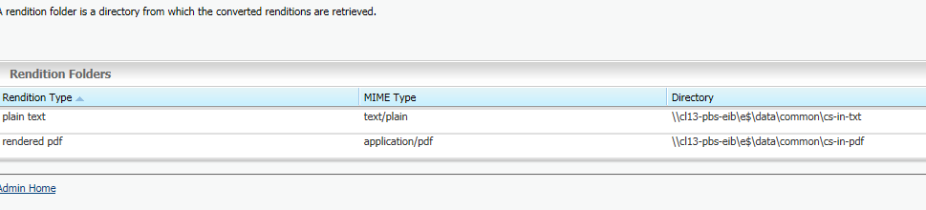

APPENDIX T: Configure Multifle setting
ged.dll?func=multifile.settings
Temporary Directory: //cl13-pbs-eib.beilux.eib.org/e$/data/common/multifile

APPENDIX U: Migrating index from cs10 to cs10.5

- Procedure to migrated index from cs10 to cs10.5 on a cs10.5 that has been upgraded already and that have a running index process.
- Insure that the number of indexes, partitions, dataflow processes (extractor, dcs, UD, ect….) are the same on cs10 and 10.5
- Stop the extractor on both instance cs10 and cs10.5 (Insure that the entreprise dataflow is empty on both instance)
- Stop the cs services on both instance cs10 and cs10.5
- Back up the database on CS10.5
- Back up the cs_home\config
- Rename the cs10.5_index\entreprise to cs10.5_index\entreprise_10.5
- Copy the cs10_index\enterprise to cs10.5_index\
- Copy the signature file from each cs10.5_index\enterprise_10.5\index1 to each cs10.5_index\enterprise\index1 (Repeat the operation all the index folder)
- On the CS 10.5 Turn on Search Debug Logging set wantDebugSearch=TRUE in opentext.ini
- On the CS 10.5 Start the CS 10.5 services on the Admin server.
- On the CS 10.5 the Enterprise data source is suspended.
- On the CS 10.5 Access the following url: func=OTAdmin.AskResyncAll&NextURL=%2Fged%2Fged%2Edll%3Ffunc%3Dadmin%2Esetup%26checkpassed%3Dy%26dbupgrade%3DN%26nextURL%3D%252Fged%252Fged%252Edll%253Ffunc%253Dadmin%252Esetup
- Insure that the DCS , file cache is configured and enable
- On cs10.5 from GUI, run a Resynchronize from admin server this will update the search.ini
- On cs10.5 from GUI Resynchronize each Partition, index engine, search (from 1 to 6), index engine, search engine
- Check the Metadata Memory Settings (On the Functions menu of the Enterprise Partition Map, click Properties-->Metadata Memory Settings.)>
Insure that they are identical from prod cs10 to preprod cs 10.5
- Start each partition manually
- After 30 min if successful the partition should start converting.
- Set extractor Setting func=indexadmin.generalsettings&redirectFunc=/ged/ged.dll?func=indexadmin.configure
MaxVersionsToExtract=5
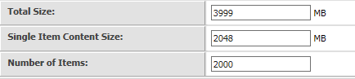
Location: /info/38992668, /info/39138686, /info/58934684
Subtype:
ExcludedNodeTypes={137,142,143,148,150,154,161,162,189,201,203,209,210,211,231,258}
ExcludedVolumeTypes={148,162,404,901,690}
Location: /info/38992668, /info/39138686, /info/58934684
- Enable index verification ?func=index.verifyagentadmin

